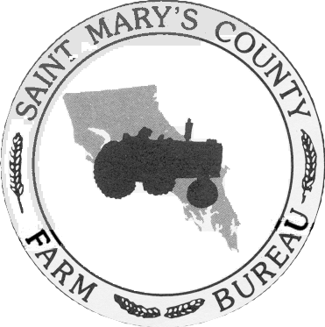
ST. MARY’S COUNTY FARM BUREAU
26737 Radio Station Way, Ste. G,
Leonardtown, MD 20650
(240) 309-4183
stmarys.mdfarmbureau.com
WORKING FOR SUSTAINABLE AGRICULTURE SINCE 1947

PRESS STATEMENT: FOR IMMEDIATE RELEASE
May 23, 2021

FARM BUREAU AWARDS 4 SCHOLARSHIPS

The St. Mary’s County Farm Bureau awarded scholarships to the following students:

$500.00 in memory of Mr. Floyd Raley to Sara Van Ryswick, who will be graduating from high school this year. She has applied to several colleges and will be majoring in Nursing.

$500.00 in memory of Mr. Robert Jarboe to Kayla Thomas, who is attending the College of Southern Maryland where she is majoring in Criminal Justice.

$500.00 Trade School scholarship awarded to Elijah N. Thomas. Elijah is attending the College of Southern Maryland Center for Trades and Energy. He is studying to become an electrician.

$1,000.00 scholarship awarded to Sophie Anderson for her service as the 2020-2021 Miss St. Mary’s County Farm Bureau. Sophie will be graduating from high school this year. She has applied to several colleges and will be majoring in Nursing.

All recipients are dependents of members of the St. Mary’s County Farm Bureau.

By authority of,

James K. Raley, Jr.
President
St. Mary’s County Farm Bureau
(301) 481-7927

PRESS STATEMENT: FOR IMMEDIATE RELEASE
May 23, 2021
Page -2-

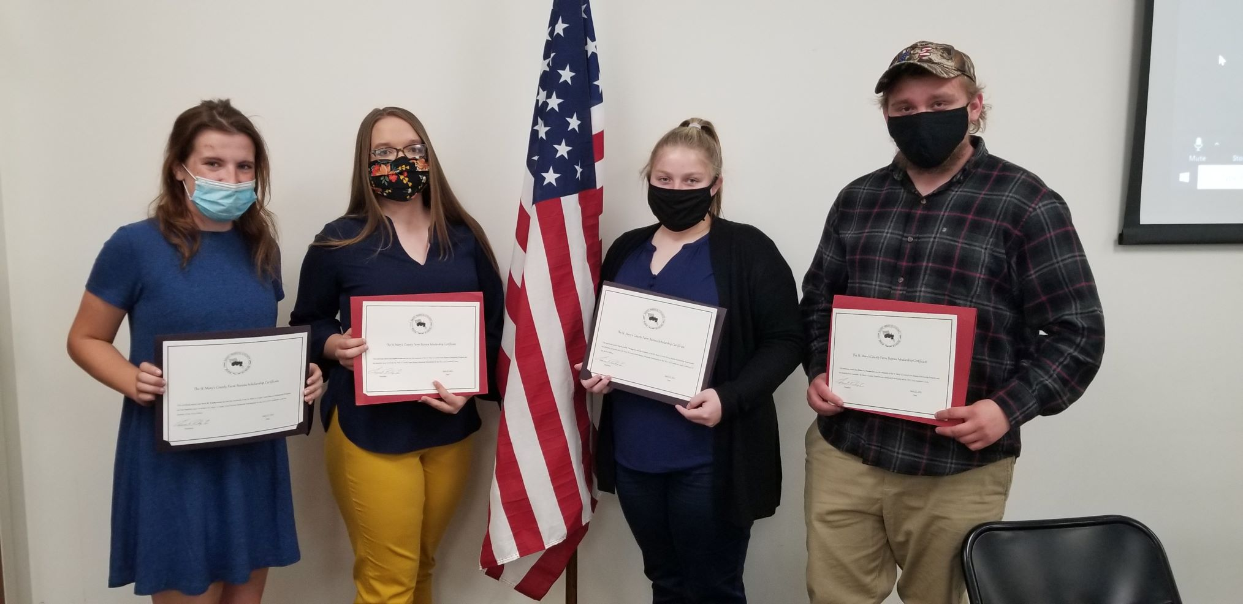

(Left to Right) Sara Van Ryswick, Sophie Anderson, Kayla Thomas, Elijah N. Thomas.

